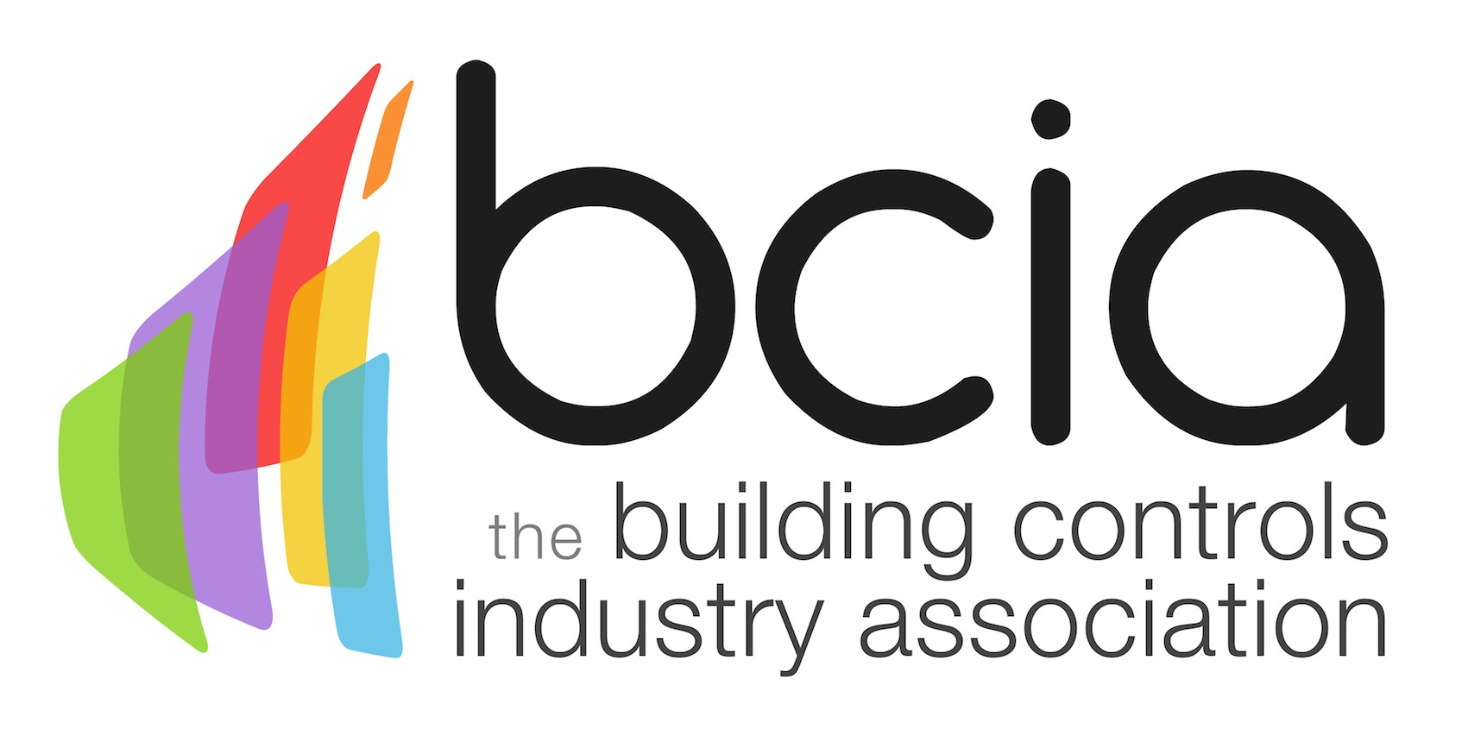

Press Release

24 May 2018

BCIA launches new and improved introductory building controls course

The Building Controls Industry Association (BCIA) is delighted to offer the perfect starting point for professionals working in the building controls industry: BCM00 Introduction to Building Controls and HVAC training course.

This is also ideal for anyone wishing to gain further understanding and insight into the world of building controls and to develop their knowledge and awareness of the subject. The BCM00 course is designed for facilities and estate managers, electricians and building services trades personnel, including marketing and PR staff.

The introductory course provides an understanding of day to day involvement in building controls and HVAC and covers topics, such as basic control of heating, types of control heating systems, primary heating plant, distribution of heating, hot water service and centralised HWS.

BCM00 also includes ventilation and air conditioning fresh air, heating & cooling with air systems, basic use of the relative humidity and psychometric chart, multi-zone system, air handling unit and air plant unit.

For those new to the building controls sector, BCM00 will help you get up to speed quickly and learn the basics. However, the course is also suitable for those who may be wishing to transfer over from another sector, such as electrical, and are considering a new career path. The introductory course offers a progression route as this can be followed by a suite of six CPD-accredited courses: BCM01-06 that cover all aspects of building controls in general detail.

This one-day introductory BCM00 training course takes place on Wednesday 26 September 2018 at the BCIA Peterborough Training Centre. All members of the BCIA can take advantage of the discounted rate of £220+VAT per delegate, or for non-members the price per delegate is £300+VAT.

Book your place today to increase your knowledge of building controls and help raise the profile of the controls industry.

For further information or to book your course, please email Hayley Hopkins: training@bcia.co.uk

www.bcia.co.uk

Note to editors
The Building Controls Industry Association (BCIA) represents the UK building controls and BEMS sector. With around 93 members accounting for 80% of the UK controls market, the BCIA is an influential group that promotes better specification, application and use of controls. The BCIA also offers its own training courses and is currently supporting a new Trailblazer Apprenticeship Standard for the industry which is being developed by the BEMS Employer Group.

For further information about the BCIA please contact Keystone Communications:

Tracey Rushton-Thorpe
Tel: 01733 294524
Email: tracey@keystonecomms.co.uk

Leandra Graves
Tel: 01733 294524
Email: leandra@keystonecomms.co.uk

