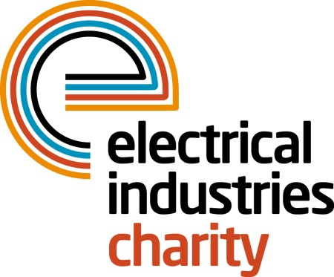

**Press Release**

**25 April 2018**

**The Charity appoints new members to the Emerging Professionals Board**

The Electrical Industries Charity welcomes nine members to the Emerging Professionals Board who will be representing the views of the younger generation and will bring a fresh perspective into the electrical sector which is needed to help the Charity and the industry to move forward.

Over the two-year period, the Board will focus on three core initiatives including the monitoring and the governance of the Big Build Project and securing revenue for the future generation through the Society Lottery. They will also be highlighting the awareness and the importance of mental health problems within the construction sector.

The nine selected members include Michael Giles of the ECA, Thomas Appleton and Juliet Muli of EDF, Samuel Ewuosho of the Department of Treasury and Energy. Also, Ollie Bishop of Ryness Electrical, Andy Reakes of Joint Industry Board (JIB), Deborah Graham-Wilson of Eland Cables, Danny Carey of Schneider Electric and Sarah Revell of R & B Star.

Samuel Ewuosho of the Department of Treasury and Energy, says: “The breadth of support the Charity provides is truly unique and desperately needed in the industry. With almost 70% of the workforce having suffered from stress, anxiety or depression - much higher than other sectors we are finally tackling the stigma associated with mental health and the systemic issues that exacerbate it in the industry.

“Joining the Emerging Professionals Board presents the chance to give something back. I look forward to being taken out of my comfort zone, working with different people from diverse backgrounds, and hopefully seeing the direct and positive impact we make in people’s lives.”

Michael Giles of the ECA added: “I had been keen to undertake a charity role for some time, and this seemed like a perfect opportunity to support a charity which is vital to the industry. Being offered the role was a privilege, and I intend to provide my input and support wherever possible to support the Electrical Industries Charity’s key objectives and current and future projects.”

Each quarter, two different members of the Emerging Professionals Board will attend the Charity’s Board meetings where they will have an opportunity to share their skills and ideas and leave a mark on the industry for the future generation. At the end of the two-year term, two of the Junior Board members will have an opportunity to become trustees for the Charity’s Trustee Board and continue to drive the industry forward.

For further information, please contact Vicky Gray: vicky.gray@electricalcharity.org

[www.electricalcharity.org](http://www.electricalcharity.org)

**Note to editors**

The Electrical Industries Charity is the national charity for the electrical, electronics and energy industries. It aims to look after people from these industries whenever they or their families need help with life’s challenges.

The charitable services are available to anyone who currently works or has worked in the very diverse and often converging industries, such as:

* Electrical contracting and facilities management
* Electrical and electronic manufacturing, wholesale, distribution and retail
* Electrical and mechanical engineering
* Lighting industry
* Generation, distribution and supply of electrical power, including nuclear and renewable energy

For further information about the Electrical Industries Charity please contact Keystone Communications:

Tracey Rushton-Thorpe Monika Gaubyte

Tel: 01733 294524 Tel: 01733 294524

Email: [tracey@keystonecomms.co.uk](mailto:tracey@keystonecomms.co.uk) Email: monika@keystonecomms.co.uk