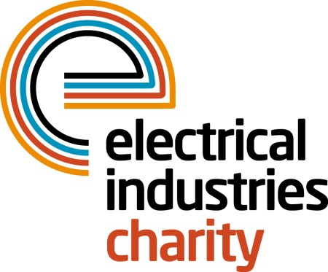
Press Release

24 May 2018

Take on the Great Wall of China challenge

Do you think you have what it takes to conquer thousands of steps of the Great Wall of China? Sign up for the Electrical Industries Charity’s Challenge for a Cause – the Great Wall of China trek 2018 and help to Raise the Roof for the Dickinson family.

The Great Wall of China (also known as Changcheng) trek is part of the Charity’s Challenge for a Cause campaign which aims to raise £250,000 for the Dickinson family and help Caz Dickinson with her development and care.

Throughout this once in a lifetime challenge, you will have a chance to experience the breath-taking scenery of one of the New Seven Wonders of the World and gain a fascinating insight into a rich culture and history. You will also have an opportunity to combat thousands of steps through terraced farmland, beautiful hills and mountains in remote areas of north Beijing.

Over the 10-days you will also venture along the contours of the world’s longest defensive fortification which was built in the 5th Century BC by the Qin Shi Huang and the Ming Dynasty and stretches up to 6,000km across China while savouring the timeless landscapes and time-weathered watchtowers. This incredible experience is taking place between 13-22 September 2018. All you need to do to take part is to sign up and raise £3,150.

As the famous Chairman Mao in his poem once said, ‘Until you reach the Great Wall, you're no hero’. Therefore, book your place today and become a hero by doing something incredible for people in your industry while having the adventure of a lifetime. Hurry, there are only a few places left available.

To book your place or for further information, please contact Sema Gornall: sema.gornall@electricalcharity.org

www.electricalcharity.org

Note to editors
The Electrical Industries Charity is the national charity for the electrical, electronics and energy industries. It aims to look after people from these industries whenever they or their families need help with life’s challenges.

The charitable services are available to anyone who currently works or has worked in the very diverse and often converging industries, such as:
- Electrical contracting and facilities management
- Electrical and electronic manufacturing, wholesale, distribution and retail
- Electrical and mechanical engineering
- Lighting industry
- Generation, distribution and supply of electrical power, including nuclear and renewable energy

For further information about the Electrical Industries Charity please contact Keystone Communications:

Tracey Rushton-Thorpe Monika Gaubyte
Tel: 01733 294524 Tel: 01733 294524
Email: tracey@keystonecomms.co.uk Email: monika@keystonecomms.co.uk

