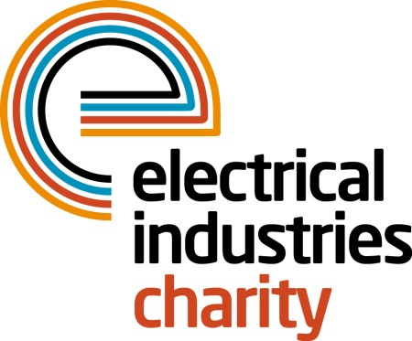
Press Release

23 April 2018

The Challenge for a Cause team breaks the ice

The Electrical Industries Charity is thrilled to announce that their team of 18 enthusiastic trekkers are back from their biggest challenge of the year, the Challenge for a Cause - Arctic Adventure 2018.

In March, a team of 18 industry trekkers joined Tessa Ogle, Managing Director of the Electrical Industries Charity and embarked on the three-day journey through the Arctic Circle of Kuusamo, Finland. They included Caz Dickinson’s daughters Jodie Dickinson, Rachel Wright and Rebecca Dickinson together with Andrew Reakes, Geoff Kerly, Darren Wetherill, Dave Gilbert, Paul Reeve, Cathy Plummer, Alan Plummer, Michael Burnard, Charlie Harwood, Paul Rhodes, and Keith Sampson. Team Stearn Electric which included Mark Booth, Kate Menzies, Scott Champion and Sean Miller also joined the challenge.

Caz’s Husband Mick, says: “If I was to thank each and every one of you every day between now and my last breath, it still wouldn’t come close to appreciating what you have all sacrificed for the Dickinson family. You have all given one week of your life, to improve ours for the rest of our lives. This incredible selfless act will change Caz’s life forever. I personally will never forget what you have done for us.”

Throughout the three days in the Arctic, the Challenge for a Cause team faced sub-zero temperatures and experienced various challenges including building their own igloos to sleep in, six hours snowshoeing, cross-country-skiing, husky sledding and the ice dip challenge in -9˚C temperatures.

Darren Wetherill, Managing Director of DW Electrical said: “The whole trip was well organised from start to finish, challenging and at times very emotional as we were really in touch with the reason we were doing the challenge and the reason we were raising money. I didn’t know what to expect when signing up for the trip all those months ago, but I couldn’t have wished for a better experience.”

The team undertook the Challenge for a Cause to the Arctic to raise money for the Dickinson family which will help Caz with her development and care and will create a better future for the whole family. So far, the team has raised an astonishing £125,716 and is halfway towards the initial target of £250,000.

It is not too late to show your support for this incredible cause and help the Dickinson family to look forward to the future.

To make your donation, please visit: http://uk.virginmoneygiving.com/fund/CFAC2018

For further information, please contact Vicky Gray: vicky.gray@electricalcharity.org

www.electricalcharity.org

Note to editors
The Electrical Industries Charity is the national charity for the electrical, electronics and energy industries. It aims to look after people from these industries whenever they or their families need help with life’s challenges.

The charitable services are available to anyone who currently works or has worked in the very diverse and often converging industries, such as:
- Electrical contracting and facilities management
- Electrical and electronic manufacturing, wholesale, distribution and retail
- Electrical and mechanical engineering
- Lighting industry
- Generation, distribution and supply of electrical power, including nuclear and renewable energy

For further information about the Electrical Industries Charity please contact Keystone Communications:

Tracey Rushton-Thorpe Monika Gaubyte
Tel: 01733 294524 Tel: 01733 294524
Email: tracey@keystonecomms.co.uk Email: monika@keystonecomms.co.uk

