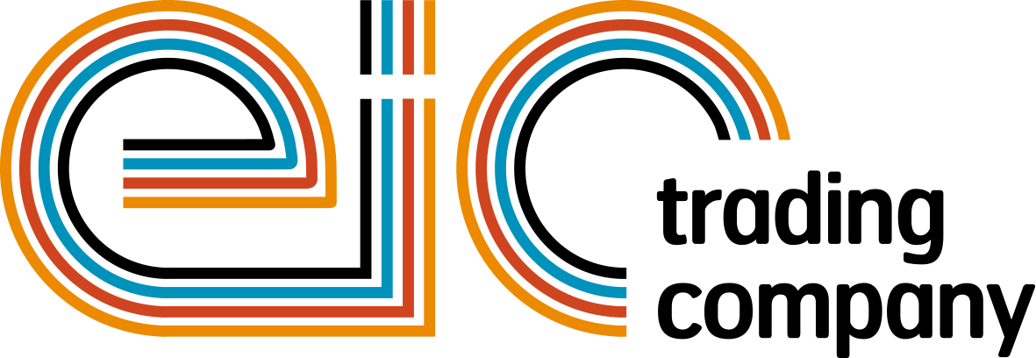

Press Release

02 May 2018

Let your company shine at powerBall 2018

Are you ready to ‘Have the Time of Your Life’ at the biggest industry event of the year? powerBall 2018 is set for another unforgettable night at the Kellerman’s Resort with City Electrical Factors (CEF) as the headline sponsor for the third year running.

This year’s phenomenal event will not leave anyone in the corner with its wide range of world-class entertainment available throughout the evening. Guests on the night will have an opportunity to enjoy the breath-taking Dirty Dancing show transporting you back to that magical summer of 1963 at the Kellerman’s Resort.

Throughout the evening guests will be infused by a mix of heart-stopping choreography combined with live singing of hits including ‘You Don’t Own Me’ and ‘Be My Baby’. The returning band - Madhen and DJ Laura will light up the evening with their high energy performance and will get your feet moving all night long to some of the greatest dance classics.

powerBall is also offering you a fantastic opportunity to stand out from the crowd and put your company in the spotlight by sponsoring one of the packages available including a brand-new Cash Cube game and Networking Lounge.

The Cash Cube Sponsorship will present you with an opportunity to place your company’s logo on the Cash Cube and paper money which guests will try to grab while it is blown by the wind machine in the Cash Cube to win some incredible prizes. This fantastic sponsorship package will also give you a chance to get maximum recognition leading up to powerBall and on the night.

The Networking Lounge Sponsorship will provide your company with a quiet zone dedicated for networking, located in the Rink Bar after the drinks reception. You will have a chance to display your company’s materials and banners in the lounge while getting recognition across all marketing platforms prior to and during the event.

Or why not show your support by donating some raffle or auction prizes? There is an opportunity for everyone to gain recognition and show their support while having a night to remember.

Managing Director, Tessa Ogle says: “We are excited to have CEF as our headline sponsor for the third year in a row and we are looking forward to welcoming the industry for another wonderful night with amazing entertainment.”

Book your place today and don’t miss this exceptional opportunity to party with hundreds of industry professionals at the most prestigious event in the electrical industry.

powerBall 2018 is taking place on Friday 09 November at Grosvenor House Hotel, London. For more information on sponsorships or to book your table, please contact Liva Ivanova: powerball@eictradingco.org

www.eictradingco.org

Note to editors
powerBall 2018 is being run by The Electrical Industries Trading Company Limited which is a wholly owned subsidiary of the Electrical Industries Charity.

The Electrical Industries Charity is the national charity for the electrical, electronics and energy industries. It aims to look after people from these industries whenever they or their families need help with life’s challenges.

The charitable services are available to anyone who currently works or has worked in the very diverse and often converging industries, such as:
- Electrical contracting and facilities management
- Electrical and electronic manufacturing, wholesale, distribution and retail
- Electrical and mechanical engineering
- Lighting industry
- Generation, distribution and supply of electrical power, including nuclear and renewable energy

www.electricalcharity.org

For further information about powerBall 2017 please contact Keystone Communications:

Monika Gaubyte
Tel: 01733 294524
Email: monika@keystonecomms.co.uk

Tracey Rushton-Thorpe
Tel: 01733 294524
Email: tracey@keystonecomms.co.uk

