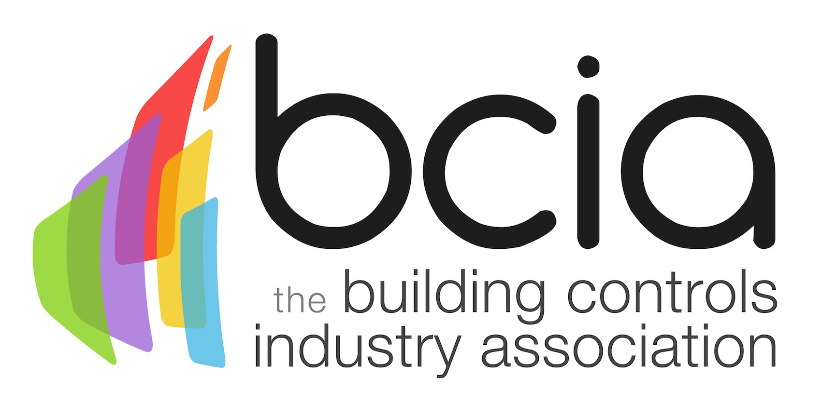

Press Release

13 June 2018

Build a successful future with new and improved BCIA training courses

The Building Controls Industries Association (BCIA) is calling on engineers, technicians, electricians and building services trades personnel to complement their existing knowledge and skillset in the building controls sector by securing their place on the new and improved BCM00-BCM06 training courses.

The controls industry has a significant role to play when it comes to improving energy efficiency in the built environment, and talented engineers are right at the heart of this. The BCIA offers a suite of seven modules designed for those who are looking to enter the fascinating world of building controls, as well as those seeking to extend their knowledge base, advance their careers and help reshape the future of the controls industry.

The industry needs talented individuals who with their valuable expertise can deliver the smart control solutions. The most effective way to achieve this is to combine hard work and experience with up to date training. The recent BCIA Awards Engineer of the Year winner, Miles Moss of Detail Design Engineering, is an excellent example who showcases the huge personal and commercial benefits of undertaking training, even after winning the Award, Miles still has further training in his sights and is certainly not sitting back on his laurels. This is a great example to all of us wherever we are with our careers. Once Miles completed the BCM04-06 training modules he was eligible for the BCIA Advanced Technical Certificate which helped him kick on with his successful career and his efforts have been duly recognised and rewarded.

In the fiercely contested Engineer of the Year category, Miles demonstrated his technical and diagnostic knowledge which are the products of effort, experience and training.

So, perhaps you are an engineer or technician who wants to take the first steps into the building controls sector? Enrol onto BCM01-03 today and kick-start an exciting career in the dynamic world of building controls. On successful completion of the three modules, delegates will be awarded the BCIA Technical Certificate and will be eligible to apply for the brand-new ECS card.

Start up your journey into building a strong future by booking onto the BCIA training courses today. For further information or to book your course, please email Hayley Hopkins: training@bcia.co.uk

www.bcia.co.uk

Note to editors
The Building Controls Industry Association (BCIA) represents the UK building controls and BEMS sector. With around 93 members accounting for 80% of the UK controls market, the BCIA is an influential group that promotes better specification, application and use of controls. The BCIA also offers its own training courses and is currently supporting a new Trailblazer Apprenticeship Standard for the industry which is being developed by the BEMS Employer Group.

For further information about the BCIA please contact Keystone Communications:

Tracey Rushton-Thorpe
Tel: 01733 294524
Email: tracey@keystonecomms.co.uk

Leandra Graves
Tel: 01733 294524
Email: leandra@keystonecomms.co.uk

