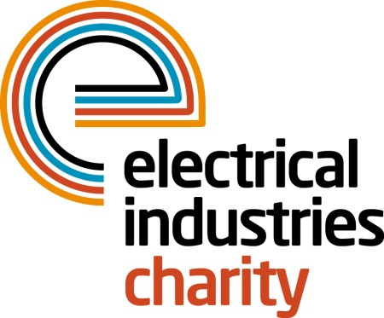
Press Release

25 June 2018

Tap the App and win big with Power Lottery

The Electrical Industries Charity is challenging everyone in the electrical and energy industries to tap the app and play Power Lottery to win big cash prizes while helping hundreds of people in the sector to have a better quality of life.

The Charity’s number one fundraising stream, Power Lottery is a fun and easy way to show your support and help the Charity to support thousands of people with practical and financial support. Thanks to the new EIC Power Lottery App you can now register, play and check your results in just one quick and easy click.

When you tap the app, you can choose to purchase between one and ten lottery numbers each month at the cost of as little as £1 per month to be in with a chance to win 15 cash prizes of up to £1,000.

Power Lottery provides the Charity with 30% of its annual income which is directly handed out in financial grants to the industry through the Charity’s Employee Assistance Programme which includes the Practical Participation, Apprentice, Pensioner, and the Family and Employee Support Programmes.

In the past year, the Electrical Industries Charity has given financial assistance grants to 672 people as well as direction and guidance to 4,154 people. You can show your support and help the Charity to make a difference to thousands of industry colleagues lives by entering Power Lottery today.

There are up to £80,000 in prizes to be won every year when you tap the app and play to help others in our industry. Are you in it to win? Test your luck and show your support by downloading the EIC Power Lottery App or enter the draw through the Charity’s official website.

For more information, please contact Vicky Gray: vicky.gray@electricalcharity.org

www.electricalcharity.org

Note to editors
The Electrical Industries Charity is the national charity for the electrical, electronics and energy industries. It aims to look after people from these industries whenever they or their families need help with life’s challenges.

The charitable services are available to anyone who currently works or has worked in the very diverse and often converging industries, such as:
- Electrical contracting and facilities management
- Electrical and electronic manufacturing, wholesale, distribution and retail
- Electrical and mechanical engineering
- Lighting industry
- Generation, distribution and supply of electrical power, including nuclear and renewable energy

For further information about the Electrical Industries Charity please contact Keystone Communications:

Tracey Rushton-Thorpe Monika Gaubyte
Tel: 01733 294524 Tel: 01733 294524
Email: tracey@keystonecomms.co.uk Email: monika@keystonecomms.co.uk

