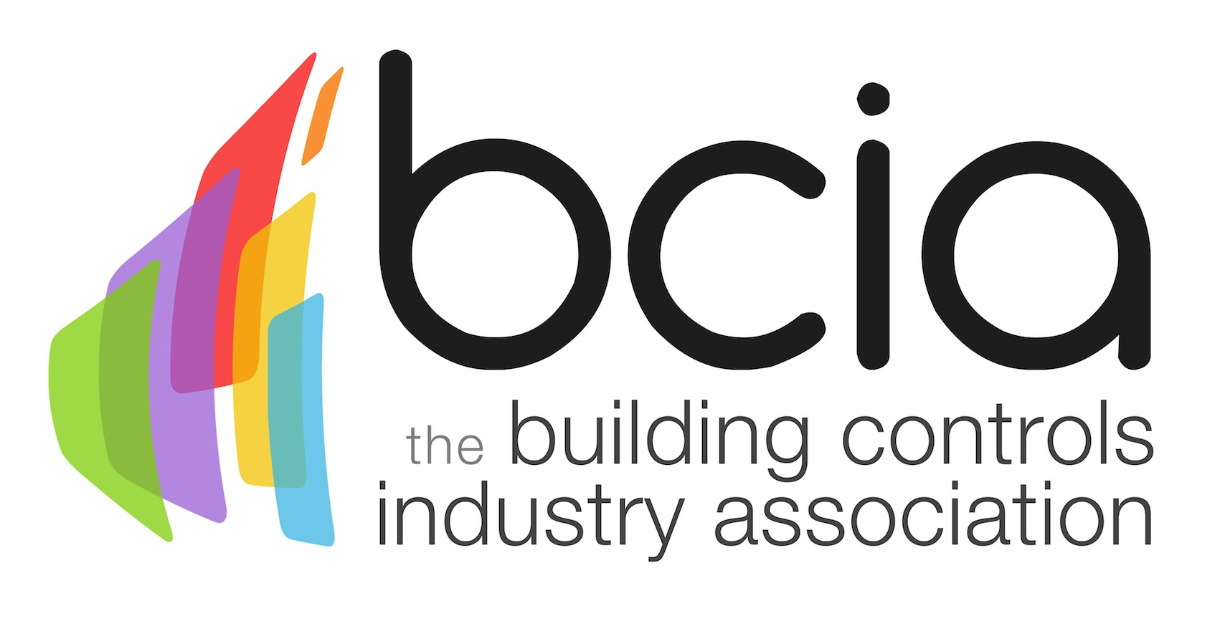

Press Release

26 July 2018

How are you handling the heat wave?

The Building Controls Industry Association (BCIA) is urging the industry to ensure that they are fully clued up on the best ways to tackle growing demands in commercial buildings to ensure optimum comfort for occupants during the summer heatwave.
The hot temperatures show no sign of disappearing and this is having a dramatic impact on some of those who work in commercial buildings. Research undertaken by Harvard University found that those working in hotter buildings performed worse in problem solving and memory tests compared to those with air conditioning.
Whereas, buildings which feature innovative and effective building controls help to improve the productivity of occupants by providing a healthy working environment.

Many smart and sophisticated building controls allow building occupants to manage their own personal preferences for their workspace in regard to ventilation, cooling and lighting.

However, opportunities are still being missed to take full advantage of the latest smart controls and solutions in today’s buildings. Therefore, the BCIA is urging both those new and experienced in the industry to invest in training.

The BCIA has recently updated its suite of seven CPD-accredited training courses. Each module has a core focus; for example, BCM01 includes an introduction to ventilation and air-conditioning, while BCM05 covers in more advanced detail the structure and modes of operation of the most common control functions used in ventilation and air conditioning plants. Knowledge gained through these modules can greatly assist improving the comfort of building occupants…

All courses are available to book throughout the year at various UK locations and feature the latest technical developments in the industry.

To book your place or for further information, please contact Hayley Hopkins: training@bcia.co.uk

Note to editors
The Building Controls Industry Association (BCIA) represents the UK building controls and BEMS sector. With around 93 members accounting for 80% of the UK controls market, the BCIA is an influential group that promotes better specification, application and use of controls. The BCIA also offers its own training courses and is currently supporting a new Trailblazer Apprenticeship Standard for the industry which is being developed by the BEMS Employer Group.

For further information about the BCIA please contact Keystone Communications:

Tracey Rushton-Thorpe
Tel: 01733 294524
Email: tracey@keystonecomms.co.uk

Leandra Graves
Tel: 01733 294524
Email: leandra@keystonecomms.co.uk

