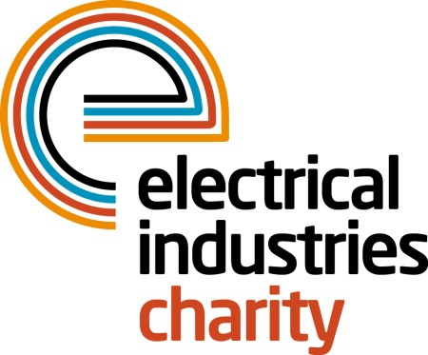
Press Release

25 July 2018

Keeping dreams alive

The Electrical Industries Charity (EIC) is looking for real-life heroes to help keep dreams alive by providing practical support or by signing up to the Charity’s very own powerLottery.

Every year EIC makes dreams come true through its Practical Participation Programme (PPP) that harnesses your specialist skills in terms of time, equipment and materials – providing practical help where it is needed most.

PPP is part of the Employee Assistance Programme (EAP) which offers a wide range of exclusive support services, complex case management and makes a significant contribution to improving the lives of apprentices, employees and their families, right through to retired colleagues.

Through PPP, EIC offers practical support to people in need like the Rhodes family. Nine-year-old William Rhodes is suffering from a rare genetic blood condition - Diamond-Blackfan Anaemia and requires blood transfusions every three weeks. William’s number one wish was to have a football pitch in his garden. EIC fulfilled his dream by laying down an all-weather football pitch using artificial grass with floodlights in his garden, so William will be able to play football all year round.

Practical assistance can go a long way to assisting in delivering large-scale solutions. You too can be part of PPP by signing up to be a partner today.

Or for as little as £1 per month you can help EIC in making dreams come true for thousands of people in the electrical industry by signing up to the Charity’s number one fundraising stream – powerLottery. Simply download the new EIC powerLottery app on your Apple or Android device and tap the app to be in with a chance of winning one of 15 cash prizes worth up to £1,000 each month.

So far over 21,000 people are taking part in powerLottery and helping EIC continue to provide life-changing support to thousands of people in their time of need.

Sign up to EIC powerLottery today and help the Charity remain the first port of call for thousands of industry colleagues and their families in the most turbulent times of their lives. To show your support, or for further information, please contact Vicky Gray: vicky.gray@electricalcharity.org

Note to editors
The Electrical Industries Charity is the national charity for the electrical, electronics and energy industries. It aims to look after people from these industries whenever they or their families need help with life’s challenges.

The charitable services are available to anyone who currently works or has worked in the very diverse and often converging industries, such as:
- Electrical contracting and facilities management
- Electrical and electronic manufacturing, wholesale, distribution and retail
- Electrical and mechanical engineering
- Lighting industry
- Generation, distribution and supply of electrical power, including nuclear and renewable energy

For further information about the Electrical Industries Charity please contact Keystone Communications:

Tracey Rushton-Thorpe Monika Gaubyte
Tel: 01733 294524 Tel: 01733 294524
Email: tracey@keystonecomms.co.uk Email: monika@keystonecomms.co.uk

