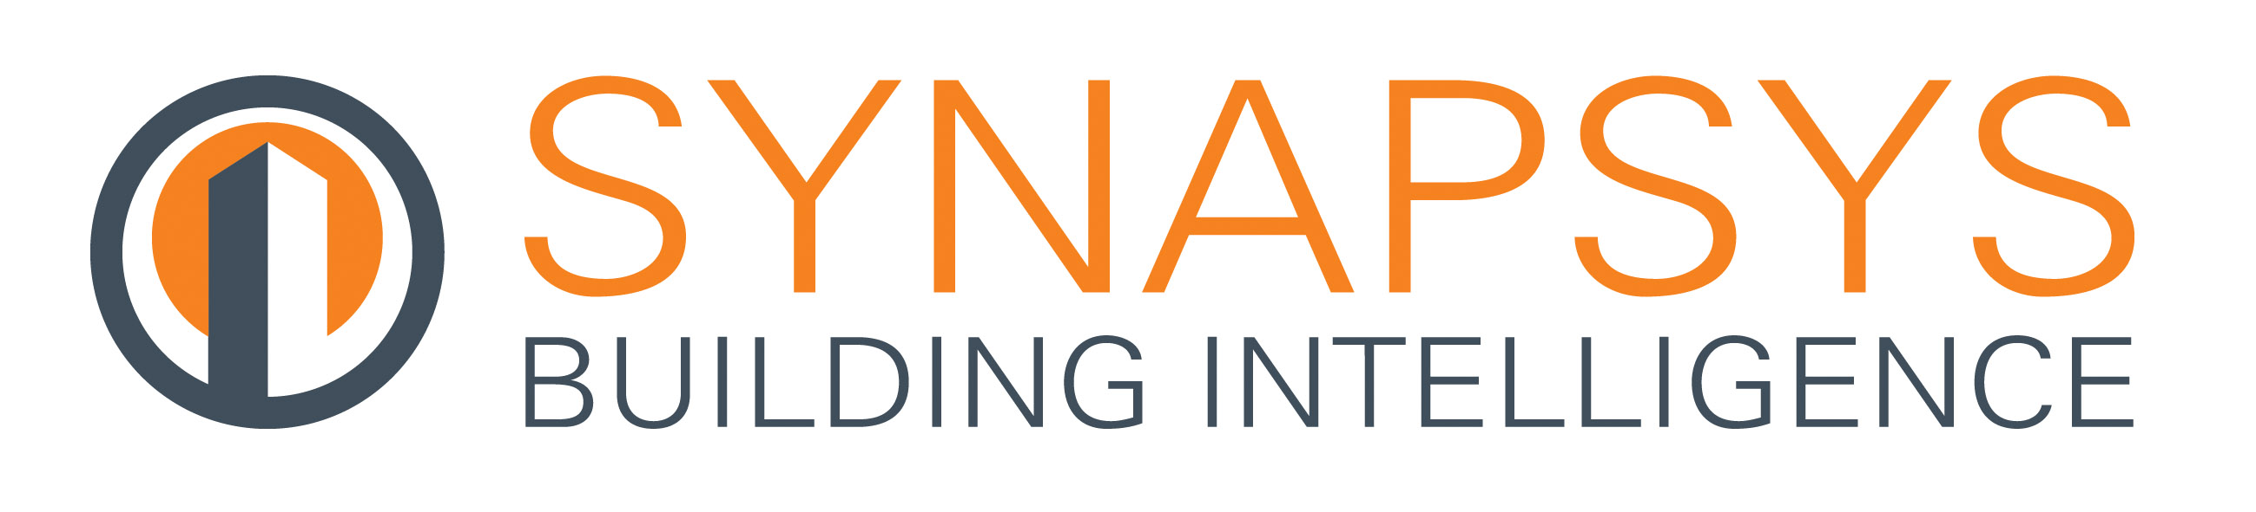

Press Release

09 July 2018

Smart Data holds the key to tackling MEES
The Minimum Energy Efficiency Standard (MEES) is now in full force, but with the renewed focus on collecting data to meet the standard, Synapsys Solutions warns of the dangers of being buried under huge amounts of useless data which is not contributing to the efficient running of the building.

Our buildings are constantly churning out data, most of which will never be used or indeed even looked at. The key is knowing the difference between Big Data and Smart Data and the power which data analytics can have in unlocking energy savings hidden in your building – all of which can contribute to achieving MEES.

Big Data refers to your digital footprint, such as making transactions on your tablet or using GPS on your mobile phone. It basically consists of a long list of numbers which have been collected over time. However, these numbers cannot be used to facilitate change alone since they make no real sense.
To successfully achieve optimum energy efficiency, it is important to think and act Smart, especially as commercial buildings are becoming more and more sophisticated.
By taking Big Data and converting it into Smart Data, through ongoing analysis and interpretation, the data becomes actionable. This can be used to pinpoint peaks and troughs in energy consumption, such as the number of offices with lights left on after 5pm or knowing how often meetings rooms are used on a particular day.

Smart Data enables building owners and managers to make informed decisions to reduce energy usage in a building and unlock potential savings. By using Smart Data and data analytics, control strategies can be determined in a building to ensure that air-conditioning is turned off at the weekend for example, or that lighting is automatically turned off when occupants leave a room.

Furthermore, underperforming plant can be identified, or equipment failures predicted, both of which save valuable time and additional maintenance costs. This goes a long way in reducing energy waste which greatly assists meeting the requirements of MEES.

Matt Gardner, Business Development Manager for Synapsys Solutions said: “The beauty of Smart Data is that it enables building owners and managers to make informed decisions and reliable predictions about your building over the long-term. Smart Data and data analytics are key to a successful energy saving strategy and meeting MEES legislation.”

www.synapsys-solutions.com

Note to editors
Synapsys Solutions offers interfacing, integration and communication solutions for the building controls industry.

The Company creates simple, cost-effective building integration solutions to improve communication and co-ordination between building, plant and equipment. Their systems reveal the operation of a building to its users, helping their customers understand, improve and optimise how their building performs.

For further information about Synapsys Solutions please contact Keystone Communications:

Tracey Rushton-Thorpe
Tel: 01733 294524
Email: tracey@keystonecomms.co.uk

Leandra Graves
Tel: 01733 294524
Email: leandra@keystonecomms.co.uk

