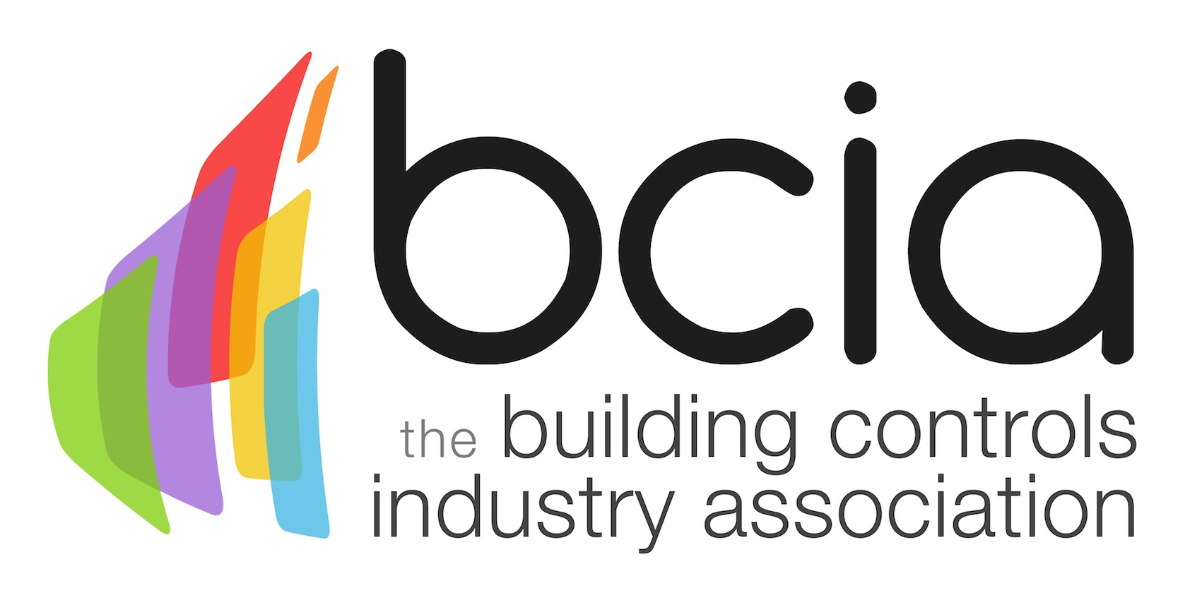

Press Release

01 October 2018

The BCIA Awards are back!

Entries are now open for the 2019 Building Controls Industry Association (BCIA) Awards and you are invited to submit your entry for the most distinguished awards ceremony in the industry’s calendar.

Anyone who is anyone will be in attendance to celebrate the excellence of the building controls industry, highlighting the fantastic achievements of talented individuals, innovative projects, products and services that the building controls sector has to offer. This prestigious event will also present you with an exclusive opportunity to network with the crème de la crème of the building controls sector at this elegant affair.

Have you or your company showcased outstanding levels of customer care or demonstrated how building controls have been applied to increase energy efficiency in a building? Perhaps you feel that one of your recent projects is playing a pivotal role in redefining the future of the building controls industry?

If so, then why not enter one of the eight award categories. There are a wide range of esteemed accolades up for grabs such as Best Service and Maintenance Provider which is sponsored by Western Automation, the Energy Management Award, sponsored by Priva or the Independent Building Controls & BEMS Installer of the Year category which is sponsored by Trend Control Systems. Alternatively, you could have your innovative skills recognised by entering Technical Innovation of the Year – Projects which is sponsored by Johnson Controls or Technical Innovation of the Year – Products which is sponsored by the BCIA.

If you are a talented Engineer over the age of 35 why not enter the Engineer of the Year category or if you are a young engineer aged between 18-35, make a name for yourself in the Young Engineer of the Year category which is sponsored by Schneider Electric. Alternatively, if you deliver excellent training in building controls, you are invited to enter the Contribution to Training Award sponsored by Siemens Building Technologies and be celebrated for your sterling achievements in front of the elite of the building controls industry.

Jon Belfield, President of the BCIA, says: “The countdown is on for the prestigious 2019 BCIA Awards ceremony which is contested by outstanding people, dynamic companies and innovative products all seeking to get in the mix for a coveted BCIA Award. It is a wonderful night in our calendar and a great opportunity to celebrate our shared values and excellence. It’s definitely a night not to be missed...”

The 2019 BCIA Awards take place on Thursday 09 May 2019 at the Hilton Birmingham Metropole and are free to enter. The deadline for entries is Friday 21 December 2018.

To stay up to date with the latest BCIA Awards news follow the BCIA on Twitter: @BCIA_news and use the official hashtag #BCIAAwards19. Alternatively, visit the official website: www.bcia.co.uk

Note to editors
The Building Controls Industry Association (BCIA) represents the UK building controls and BEMS sector. With around 93 members accounting for 80% of the UK controls market, the BCIA is an influential group that promotes better specification, application and use of controls. The BCIA also offers its own training courses and is currently supporting a new Trailblazer Apprenticeship Standard for the industry which is being developed by the BEMS Employer Group.

For further information about the BCIA please contact Keystone Communications:

Tracey Rushton-Thorpe
Tel: 01733 294524
Email: tracey@keystonecomms.co.uk

Leandra Graves
Tel: 01733 294524
Email: leandra@keystonecomms.co.uk

