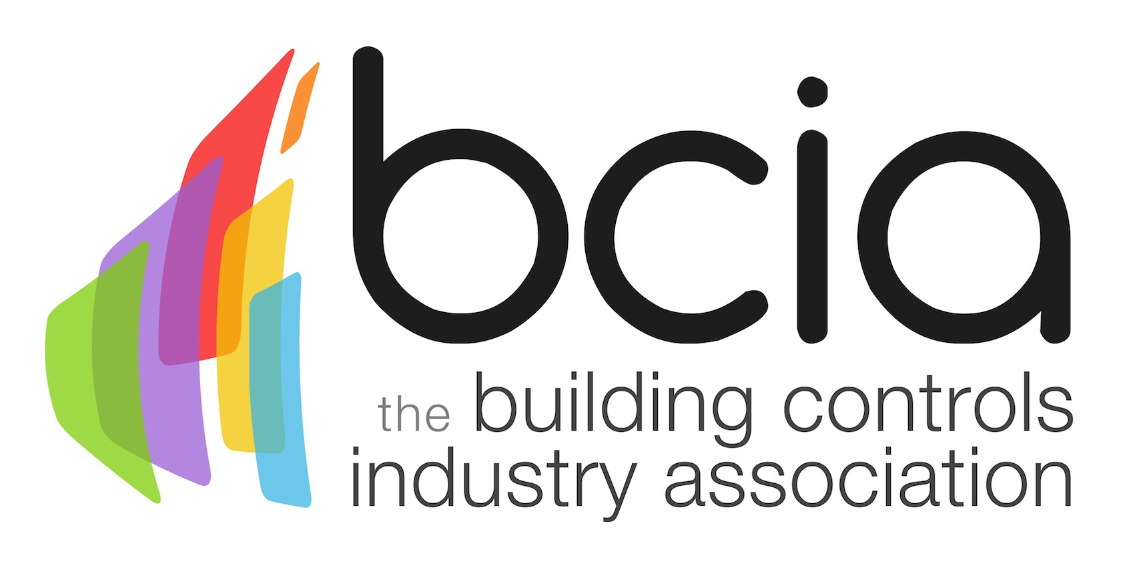

09 August 2018

Does wellbeing need to be regulated?
The topic of wellbeing continues to create discussion in all quarters – and it is highly prevalent in the building controls sector. Therefore, the Building Controls Industry Association (BCIA) ponders the question of whether wellbeing needs to be regulated in reference to commercial buildings…

While there is legislation in place concerning energy efficiency, there is nothing in place regarding wellbeing, despite the growing demands around the subject. The Minimum Energy Efficiency Standard (MEES) is a prime example of how legislation results in prompt action – as landlords are unable to let out buildings that have an Energy Performance Certificate (EPC) rating of “E” or below until they make the necessary improvements.

The built environment has a significant role to play in regard to people’s wellbeing. It is well documented that building occupants enjoy some level of control over their workspace and are proven to be more productive as a result. Sophisticated technology is creating more opportunities to tackle wellbeing through a vast range of building controls, many of which allow users to dictate their own personal preferences for heating, ventilation, air conditioning and lighting.

However, with ongoing advancements in technology, it is important that those people responsible for operating innovative controls in the workplace, have a full and confident understanding of how best to extract smart controls to their full potential – to avoid missed opportunities.

Optimum wellbeing in a building can be achieved from as early on as the design stage of a build – and legislation would ensure that everyone is working from the same standard in order to develop a building that best meets the needs of the occupants using it.

Jon Belfield, President of the Building Controls Industry Association (BCIA) said: “The term ‘wellbeing’ can be highly subjective with different meanings for different individuals. While each case is unique, it is clear that collectively within the industry, we need to adopt a change of culture and embrace wellbeing. Following a set of precise requirements would help ensure that this is easily achieved with benefits for building owners and occupants alike…”

www.bcia.co.uk

Note to editors
The Building Controls Industry Association (BCIA) represents the UK building controls and BEMS sector. With around 93 members accounting for 80% of the UK controls market, the BCIA is an influential group that promotes better specification, application and use of controls. The BCIA also offers its own training courses and is currently supporting a new Trailblazer Apprenticeship Standard for the industry which is being developed by the BEMS Employer Group.

For further information about the BCIA please contact Keystone Communications:

Tracey Rushton-Thorpe
Tel: 01733 294524
Email: tracey@keystonecomms.co.uk

Leandra Graves
Tel: 01733 294524
Email: leandra@keystonecomms.co.uk

