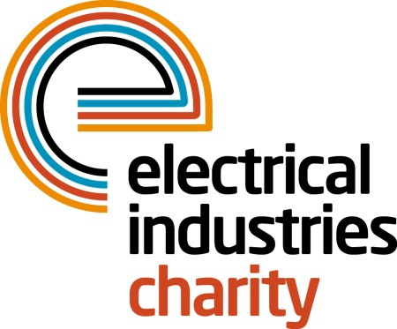
Press Release

12 October 2018

Big Build Project partner with architect Dhiran Vagdia
The Electrical Industries Charity is delighted to announce a partnership with architect Dhiran Vagdia of Vagdia and Holmes for Challenge for a Cause – the Big Build Project.
The Big Build Project aims to raise £250,000 to purchase a house to transform daily life for Caz Dickinson and her family. This is the first partnership of its kind and a very important milestone in helping Caz to regain her independence in a new home which will feature modifications to help her move around with more ease.

As a vastly experienced architect, Dhiran and his team will play a crucial role in helping Caz regain her independence in the purchased house which will be designed and adapted to best suit her needs.

Dhiran Vagdia, Director of Vagdia and Holmes said: “The main reason we got involved with the Big Build Project was to help. We regularly take on projects that require a special set of spaces to allow occupants to move around the home with more ease. Caz’s situation is obviously very rare and it’s great that EIC are in a position to help her and her family, thanks to the kind donations they receive. We can’t wait to get involved and get started!”

Once the house has been purchased, Dhiran and his team will work with Caz and her family to discuss the design brief. Following this, the focus will be on obtaining planning permission and designing and testing various solutions to see what best suits the needs of the family.

Claire Shelton, Programme Manager of the Big Build Project said: “We decided to go into partnership with Dhiran as he’s highly experienced in disability adaptions, has great communication skills and is very passionate about what he does. What’s more, Dhiran is a family man and appreciates how much this will mean to Caz and her family. He is also local and that was really important to us as ideally, we want to keep business within the Coventry and Warwickshire area. Currently, we are trying to locate a suitable property in the area, so that we can begin renovation immediately.”

The aim is to have this new house fully renovated and ready for Caz and her family to move in by Summer 2019. The Charity has raised over £160,000 to date thanks to support from the industry. If you would like to help Big Build Project reach their target, you can donate here: https://uk.virginmoneygiving.com/charity-web/charity/displayCharityCampaignPage.action?charityCampaignUrl=CFAC2018

www.electricalcharity.org

Note to editors
The Electrical Industries Charity is the national charity for the electrical, electronics and energy industries. It aims to look after people from these industries whenever they, or their families need help with life’s challenges. It provides information, financial grants and practical support on a range of everyday issues including; work, family, relationships, money and health.

The charitable services are available to anyone who currently works or has worked in the very diverse and often converging industries, such as:
- Electrical contracting and facilities management
- Electrical and electronic manufacturing, wholesale, distribution and retail
- Electrical and mechanical engineering
- Lighting industry
- Generation, distribution and supply of electrical power, including nuclear and renewable energy

For further information about the Electrical Industries Charity please contact Keystone Communications:

Tracey Rushton-Thorpe Leandra Graves
Tel: 01733 294524 Tel: 01733 294524
Email: tracey@keystonecomms.co.uk Email: leandra@keystonecomms.co.uk

