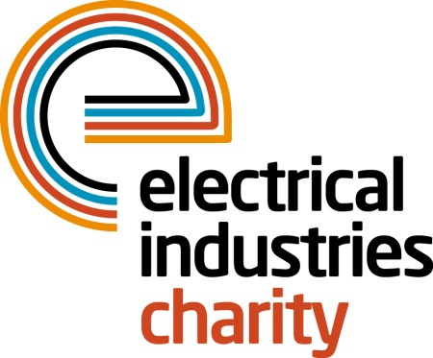
Press Release

23 October 2018

Challenge for a Cause team conquers one of the Seven Wonders of the World

The Electrical Industries Charity (EIC) is thrilled to announce that the team of three selfless trekkers are back from the biggest challenge of the year – the Great Wall of China 2018.

In September, the team of three enthusiastic trekkers including Mark Doré of Edmundson Electrical, Monika Gaubyte of Keystone Communications and Jess Vailima of the Electrical Industries Charity (EIC), embarked on the 10-day journey of a lifetime to one of the Seven Wonders of the World – the Great Wall of China with the aim to raise money for the Dickinson family.

The adventure of a lifetime started in the small town of Huyangyaguan which is located 75 miles from downtown Beijing in the beautiful valley of the Yanshan Mountains, where the team tackled over 22,000 steep renovated steps until they reached the ‘Heaven’s Ladder’.

During the 10-day journey, the team of three trekkers got to explore the well-preserved and unrestored parts of the Great Wall including remote areas of Jinshanling, Gubeikou and Badaling as they followed the contours of beautiful mountains, hills, terraced farmland and woodlands. Throughout their trip, the team were faced with many challenges as they tackled an endless amount of uneven flights of stairs, scattered dirt paths and steep rocky hillsides. However, it was all worth it as they were rewarded with a breath-taking panorama and fascinating rolling purple hills fading into the distance, dotted with dozens of historical watchtowers, and they knew that their efforts will help to change the lives of Caz Dickinson and her family.

Mark Doré of Edmundson Electrical, said: “We met up as 14 strangers, shared amazing experiences, laughed our way through the hard times and came back the closest of friends with memories to savour for the rest of our lives.”

In 10 days, the team completed over 158,000 steps and trekked an incredible 107 kilometres to show their support for the Dickinson family. The Challenge for a Cause campaign has so far raised £161,881 out of the initial £250,000 target. You can still show your support by donating on the Electrical Industries Charity’s website and help to transform a house into a home for the Dickinson family.

Caz’s husband Mick in his letter to the team, said: “Your sheer dedication, courage and determination on this trip has been absolutely amazing. For each and every one of you to take the time, money, effort and commitment to do what you have done for our family, I am not sure I will ever be able to thank you enough and will never forget what you have done for us.”

To show your support and help the EIC to secure a better future for the Dickinson family, please visit: https://www.electricalcharity.org/index.php/fundraising/our-fundraisers

Alternatively, if you would like to take part in a wide range of fundraising events that EIC has to offer, please contact Jess Vailima: jess.vailima@electricalindustriescharity.org

www.electricalindustriescharity.org

Note to editors
The Electrical Industries Charity is the national charity for the electrical, electronics and energy industries. It aims to look after people from these industries whenever they, or their families need help with life’s challenges. It provides information, financial grants and practical support on a range of everyday issues including; work, family, relationships, money and health.

The charitable services are available to anyone who currently works or has worked in the very diverse and often converging industries, such as:
- Electrical contracting and facilities management
- Electrical and electronic manufacturing, wholesale, distribution and retail
- Electrical and mechanical engineering
- Lighting industry
- Generation, distribution and supply of electrical power, including nuclear and renewable energy

For further information about the Electrical Industries Charity please contact Keystone Communications:

Tracey Rushton-Thorpe Monika Gaubyte
Tel: 01733 294524 Tel: 01733 294524
Email: tracey@keystonecomms.co.uk Email: monika@keystonecomms.co.uk

