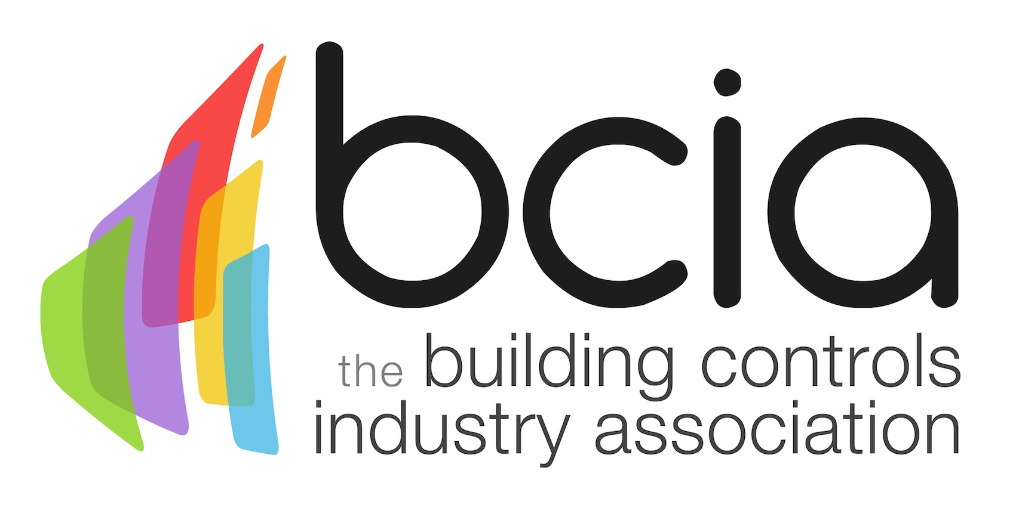

Press Release

28 November 2018

Building controls vital to compliance

The Building Controls Industry Association (BCIA) is encouraging the wider industry to consider the importance of implementing effective building controls from the outset of building projects in order to meet current legislation.

The 10 80 10 rule represents the total lifetime costs of a building, whereby only 10% of costs are invested at the design stage while a staggering 80% is spent on the running and maintaining of a building.

The BCIA is calling for a change in approach from those in the supply chain at the initial stages of building projects. By investing in an efficient controls system at the start of construction, this will dramatically lower operational costs in commercial buildings over the long term while also helping to meet a wide range of legislation.

A good example of this is the Minimum Energy Efficiency Standard (MEES) which came into force earlier this year. It is now unlawful for a landlord to let or renew a lease on a property if the Energy Performance Certificate (EPC) rating is F or G.

By installing additional zone control for instance, or demand control of lighting and heating using occupancy sensors, your EPC rating can receive a welcome boost and substantially lower unnecessary energy usage. It is these relatively simple additions to the BMS system that have a significant impact on the EPC rating.

Energy efficiency in commercial buildings remains a high priority and something that must be continually be addressed in the need to meet current and new legislation.

One of the best ways that this can be accomplished is by bearing in mind the 10 80 10 concept from the outset of construction projects and making sensible and strategic decisions to future-proof today’s sophisticated buildings. Through the implementation of innovative control systems, this will enable the wider industry to comply with legislation over the upcoming years.

For further information, please visit www.bcia.co.uk

Note to editors
The Building Controls Industry Association (BCIA) represents the UK building controls and BEMS sector. With around 93 members accounting for 80% of the UK controls market, the BCIA is an influential group that promotes better specification, application and use of controls. The BCIA also offers its own training courses and is currently supporting a new Trailblazer Apprenticeship Standard for the industry which is being developed by the BEMS Employer Group.

For further information about the BCIA please contact Keystone Communications:

Tracey Rushton-Thorpe
Tel: 01733 294524
Email: tracey@keystonecomms.co.uk

Leandra Graves
Tel: 01733 294524
Email: leandra@keystonecomms.co.uk

