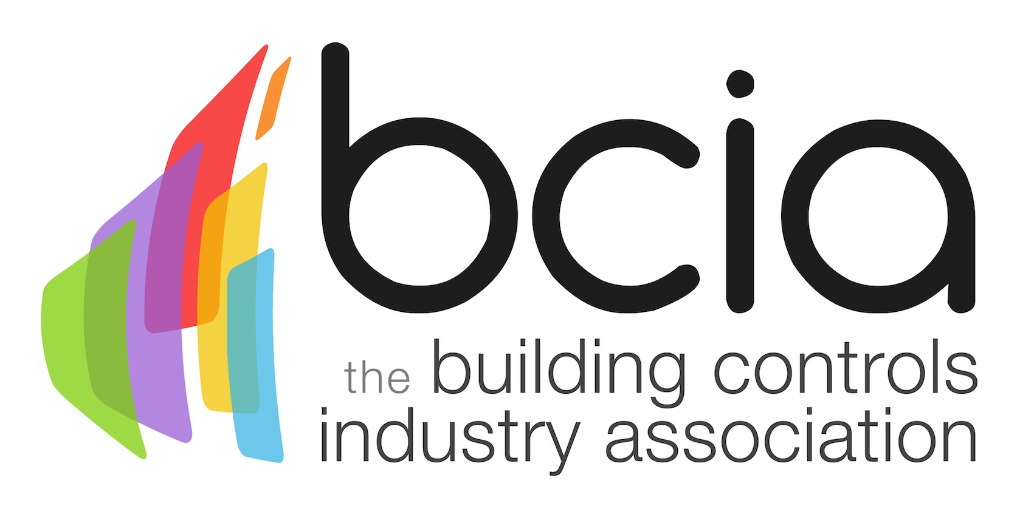

Press Release

12 November 2018

Be crowned the best at the 2019 BCIA Awards
Do you have what it takes to be crowned the best of the best in the building controls industry? If the fierce competition is no match for you - prove it by entering the 2019 Building Controls Industry Association (BCIA) Awards today.

The prestigious awards ceremony returns for yet another spectacular night and is the night that matters most to anyone who is anyone in the dynamic building controls industry. If you want to get your company noticed and show everyone that you’re at the top of your game, there is no time to lose – simply enter online today.

Judged by an independent expert panel using clearly defined criteria, even the judges don’t actually know who wins each category until the envelope is opened on the night. As you would hope, the judging is rigorous but fair, meaning the best will win.

If you’ve designed a ground-breaking product to change the way the market operates or completed an innovative project that sets you apart from your rivals, waste no time in heading over to the BCIA website. By entering the Technical Innovation of the Year – Products or Projects categories, you could be the one receiving all of the glory after collecting a highly sought-after accolade at the Awards ceremony which is held at the Hilton Birmingham Metropole on 9 May 2019.

Alternatively, if you or your colleague has excelled in the field of engineering, put yourselves in the spotlight and enter the Engineer or Young Engineer of the Year award and show the industry why you deserve to stand out from the crowd.

Perhaps training is your forte in this fast moving industry? If so, nominate your company for the Contribution to Training Award or an organisation that you have benefited from by receiving exceptional training. Other categories to enter include: Independent Building Controls and BEMS Installer of the Year, Best Service and Maintenance Provider and the Energy Management Award – all of which are up for grabs for remarkable people like you.

The distinguished Awards ceremony is the number one event in the building controls calendar to be seen at. Seize the opportunity to be crowned the best of the best by heading over to the BCIA website but don’t leave it too late as entries close on Friday 21 December 2018.

https://bcia.co.uk/awards/categories/

To stay up to date with the latest BCIA Awards news, follow the BCIA on Twitter: @BCIA_news and don’t forget to use #BCIAAwards19.

Note to editors
The Building Controls Industry Association (BCIA) represents the UK building controls and BEMS sector. With around 93 members accounting for 80% of the UK controls market, the BCIA is an influential group that promotes better specification, application and use of controls. The BCIA also offers its own training courses and is currently supporting a new Trailblazer Apprenticeship Standard for the industry which is being developed by the BEMS Employer Group.

For further information about the BCIA please contact Keystone Communications:

Tracey Rushton-Thorpe
Tel: 01733 294524
Email: tracey@keystonecomms.co.uk

Leandra Graves
Tel: 01733 294524
Email: leandra@keystonecomms.co.uk

