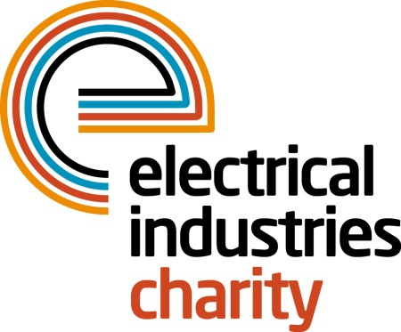
Press Release

13 November 2018

The Electrical Industries Charity urges the industry to show their support for employees and their families

The Electrical Industries Charity (EIC) launched the Employee and Family Support Programme (EFP) to give a helping hand to employees and their families in their time of need. The Charity is encouraging the industry to sign up to the Programme today and give hope for a better tomorrow to thousands of people within the electrical sector.

Staff productivity is a critical factor for any organisation but equally as important is recognising the personal life of employees. Every year there are hundreds of families within the sector who are faced with unexpected challenges in their lives and have no one to turn to for that essential support. This is why EIC launched the Employee and Family Support Programme, which is solely funded by powerLottery and is part of the Employee Assistance Programme (EAP).

Through the Employee and Family Support Programme EIC is able to provide financial relief and practical support services to people and their immediate families who have worked or are working in electrical and energy-related industries. The support services that EIC offers include debt advice, telephone counselling, carer support network, career advice and financial assistance and grants which helps to address issues such as family or relationship problems, mental health issues, ill health and disability.

Over the years, EIC has supported thousands of employees and their families and given them an opportunity to move forward with their lives. Now you too can make a huge difference in someone’s life and help EIC to not only give vital support to those who are struggling but also to turn their dreams into reality and give hope for the future.

We never know when our lives can take an unexpected turn, but as an industry we can ensure that our employees have the support they need when they need it. EFP has been proven to facilitate timely intervention that better manages outcomes for individuals, families and businesses. Once you sign up to the programme all of the services that EIC provides are completely free of charge, which means the sooner you sign up to the Programme, the sooner EIC will be able to look out for your employees and their loved ones.

Sign up to become a partner of the Employee and Family Support Programme or take part in powerLottery today and help your colleagues to take the first step in overcoming their life challenges and look forward to the future.

For further information or to take part, please contact Jess Vailima: jess.vailima@electricalcharity.org

www.electricalcharity.org

Note to editors
The Electrical Industries Charity is the national charity for the electrical, electronics and energy industries. It aims to look after people from these industries whenever they, or their families need help with life’s challenges. It provides information, financial grants and practical support on a range of everyday issues including; work, family, relationships, money and health.

The charitable services are available to anyone who currently works or has worked in the very diverse and often converging industries, such as:
- Electrical contracting and facilities management
- Electrical and electronic manufacturing, wholesale, distribution and retail
- Electrical and mechanical engineering
- Lighting industry
- Generation, distribution and supply of electrical power, including nuclear and renewable energy

For further information about the Electrical Industries Charity please contact Keystone Communications:

Tracey Rushton-Thorpe Monika Gaubyte
Tel: 01733 294524 Tel: 01733 294524
Email: tracey@keystonecomms.co.uk Email: monika@keystonecomms.co.uk

