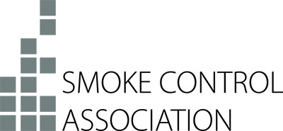

Press Release
5th November 2018

SCA signs up to support 100% Hackitt initiative

The Smoke Control Association (SCA) has declared its backing for a new industry initiative launched to encourage the government to deliver on all of the recommendations laid out in Dame Judith Hackitt’s independent review of building regulations and fire safety processes.

The 100% Hackitt initiative, introduced by the Local Authority Building Control (LABC) and the British Board of Agrément (BBA), is drawing support from across the construction and fire safety sectors and the SCA has now added its name to the growing list of organisations and industry professionals calling for a complete system change and full implementation of Dame Judith’s recommendations.

Alongside a new website – www.100-hackitt.co.uk – the organisers of the initiative have produced ‘pledge cards’ for supporters to sign and are pushing for an Early Day Motion debate in the House of Commons.

The SCA has previously outlined its desire to see the government carry out a radical overhaul of the Building Regulations and tackle critical flaws in fire safety procedures. David Mowatt, chair of the SCA, comments, “Following the Grenfell Tower tragedy the SCA submitted proposals to the review team and offered advice on improving smoke control guidelines within the Building Regulations. The SCA would now like to see action on all 53 recommendations contained within the review and offers its full support to the 100% Hackitt initiative.”

For further information about the 100% Hackitt initiative visit: www.100-hackitt.co.uk.

Note to Editors
The Smoke Control Association (SCA) is an independent body of experts all involved in various aspects of the smoke control sector. The Association works in many fields including the publication of guides related to smoke control systems and products.
The SCA is part of FETA – the Federation of Environmental Trade Associations – a UK body representing the interests of over 400 manufacturers, suppliers, installers and contractors within heating, ventilating, building controls, refrigeration and air conditioning.

For further information, please contact Keystone Communications:

Michael Crane
Tel: 01733 294524
Email: michael@keystonecomms.co.uk

