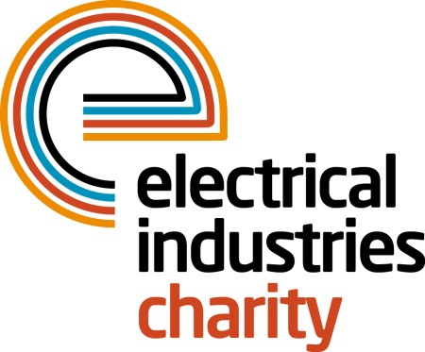
Press Release

10 December 2018

Have you got what it takes to take on the Challenge for a Cause in 2019?

Are you a brave individual who is looking for a new challenge in 2019? The Electrical Industries Charity (EIC) is offering you an incredible opportunity to take on one of the two life-changing challenges in the new year - Everest Base Camp Challenge and the Croatia Sailing Challenge.

Would you like to test your body and mind while creating memories to savour for the rest of your life? Then why not join the Electrical Industries Charity’s Managing Director Tessa Ogle on one of the most popular trekking routes in the Himalayas - Everest Base Camp - and experience the culture of Sherpa people while taking in the spectacular views of the highest mountain in the world, which stands at 8,848m above sea level. All you need to do to take part in this once in a lifetime experience is sign up and raise £5,000. This incredible Challenge for a Cause is taking place between 28th September - 10th October 2019.

Or if hiking is not for you, why not sail away into the Adriatic Sea by signing up to the Croatia Sailing Challenge for a Cause? During this incredible challenge, you will have an opportunity to be part of an internationally recognised event, the 15th IT Regatta 2019 CIO Business World Cup, and race around the stunning turquoise blue waters of the Croatian coast. The Croatia Sailing Challenge is taking place between 16th - 21st September 2019 and the fundraising target is £2,500.
Are you ready for a challenge in 2019? If so, sign up to EIC’s Challenge for a Cause 2019 - Mount Everest Base Camp trek or Croatia Sailing Challenge today and create unforgettable memories in 2019 while helping your industry colleagues in need.
For further information or if you would like to sign up to one or both of these incredible challenges, please contact, Jess Vailima: jess.vailima@electricalcharity.org

www.electricalcharity.org

Note to editors
The Electrical Industries Charity is the national charity for the electrical, electronics and energy industries. It aims to look after people from these industries whenever they, or their families need help with life’s challenges. It provides information, financial grants and practical support on a range of everyday issues including; work, family, relationships, money and health.

The charitable services are available to anyone who currently works or has worked in the very diverse and often converging industries, such as:
- Electrical contracting and facilities management
- Electrical and electronic manufacturing, wholesale, distribution and retail
- Electrical and mechanical engineering
- Lighting industry
- Generation, distribution and supply of electrical power, including nuclear and renewable energy

For further information about the Electrical Industries Charity please contact Keystone Communications:

Tracey Rushton-Thorpe Monika Gaubyte
Tel: 01733 294524 Tel: 01733 294524
Email: tracey@keystonecomms.co.uk Email: monika@keystonecomms.co.uk

