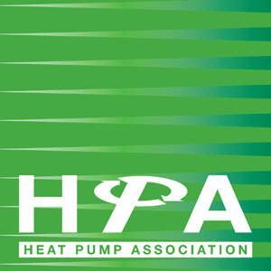

Press Release
22nd February 2019

HPA highlights benefits of heat pumps in wake of report by Committee on Climate Change

The Heat Pump Association (HPA) has welcomed a report by the Committee on Climate Change (CCC) that calls for a ban on gas boilers in homes by 2025.

The report, ‘UK housing: Fit for the future?’, calls on the government to get serious about tackling emissions from homes, warning that the UK’s legally-binding climate change targets will not be met without the near-complete elimination of greenhouse gas emissions from UK buildings.

The Heat Pump Association believes that it is vital that key people in industry are aware of the potential of heat pumps for low carbon heating. Heat pumps supply more energy than they consume, by extracting heat from their surroundings. Currently heat pump systems can supply as much as 3kW of heat output for just 1kW of energy input. In many systems, heat is transferred from outside air or from warm exhaust air. In other types of system the heat can be drawn from the ground, or water sources such as rivers or waste water.

Graham Wright, Chairman of the HPA, commented, “Although a major short term shift to solely heat pumps would be impractical, extension of the gas grid in rural areas severely risks creating a much bigger negative legacy for the future. What cannot be denied is the ability of heat pump systems of all genres to significantly reduce carbon emissions, even at quite modest system efficiencies, compared to combustion based heating.”

Graham Hazell, consultant to the HPA, will be giving evidence to the House of Commons Science & Technology Committee at Westminster on Tuesday 26th February 2019 on this subject. The discussion forms part of the Committee’s inquiry into technologies for meeting clean growth emissions reductions targets, and will be available to view live on Parliament TV.

The HPA is the UK’s leading authority on the use and benefits of heat pump technology, influencing legislation and other matters that affect the interests of its industry.

www.heatpumps.org.uk

For further information, please contact Keystone Communications:

Russell Drury
Tel: 01733 294524
Email: russell@keystonecomms.co.uk

Michael Crane
Tel: 01733 294524
Email: michael@keystonecomms.co.uk

