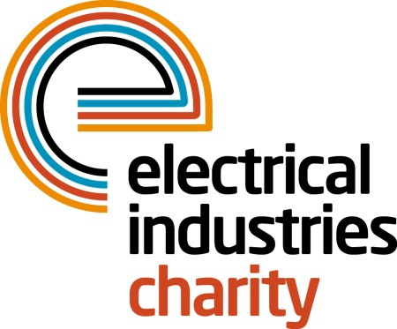
Press Release

27 March 2019

EIC offers vital support for young talent through the Apprentice Support Programme

The Electrical Industries Charity (EIC) launched the Apprentice Support Programme (ASP) to help young talent reach their full potential in the electrical sector and is encouraging the industry to show its support.

Apprenticeships are crucial in the electrical sector and can bring endless benefits, not just for young talented individuals who are seeking to build rewarding careers and become the leaders of tomorrow, but also for companies who are looking to stay competitive in the market and bring fresh ideas and skills into the sector.

According to the 2017 Apprenticeship Evaluation Survey, 67% of employers say that employing apprentices improved staff retention as well as their image in the sector. Additionally, the same report showed that 86% of employers said that apprentices helped to develop relevant skills for the organisation and to fill the skills gap.

Many young people in the electrical sector believe that the best thing about becoming an apprentice is being given a chance to learn from doing a real job and the fact that they are treated as an asset who can add real value to the company. But becoming an apprentice is by no means easy and the need to balance work and study can be tough, especially if there are added pressures in their personal lives.

The Electrical Industries Charity recognises the resilience of young people in the electrical sector and this is why EIC launched the Apprentice Support Programme, which is part of the Charity’s Employee Assistance Programme and is solely funded by powerLottery.

ASP is designed to help young people deal with some of the key challenges that affect them as they work towards their apprenticeship. The Programme offers young talent a wide range of support services, including financial and counselling support, career development and transition assistance, an apprentice bursary scheme, electrical engineering scholarships, as well as practical support.

Early intervention and a solid support network can have a huge impact on young individuals who are struggling to reach their goals and prosper due to obstacles standing in their way.

So why not show your support for young talent in the electrical sector and give them the opportunity to build a successful career and prosperous future for themselves by becoming a partner of the Apprentice Support Programme today or signing up to powerLottery for as little as £1 per month. All you need to do to take part is to download the EIC powerLottery app and tap the app to play.

For further information or to take part, please contact Jess Vailima:
jess.vailima@electricalcharity.org

www.electricalcharity.org

Note to editors
The Electrical Industries Charity is the national charity for the electrical, electronics and energy industries. It aims to look after people from these industries whenever they, or their families need help with life’s challenges. It provides information, financial grants and practical support on a range of everyday issues including; work, family, relationships, money and health.

The charitable services are available to anyone who currently works or has worked in the very diverse and often converging industries, such as:
- Electrical contracting and facilities management
- Electrical and electronic manufacturing, wholesale, distribution and retail
- Electrical and mechanical engineering
- Lighting industry
- Generation, distribution and supply of electrical power, including nuclear and renewable energy

For further information about the Electrical Industries Charity please contact Keystone Communications:

Tracey Rushton-Thorpe Monika Gaubyte
Tel: 01733 294524 Tel: 01733 294524
Email: tracey@keystonecomms.co.uk Email: monika@keystonecomms.co.uk

