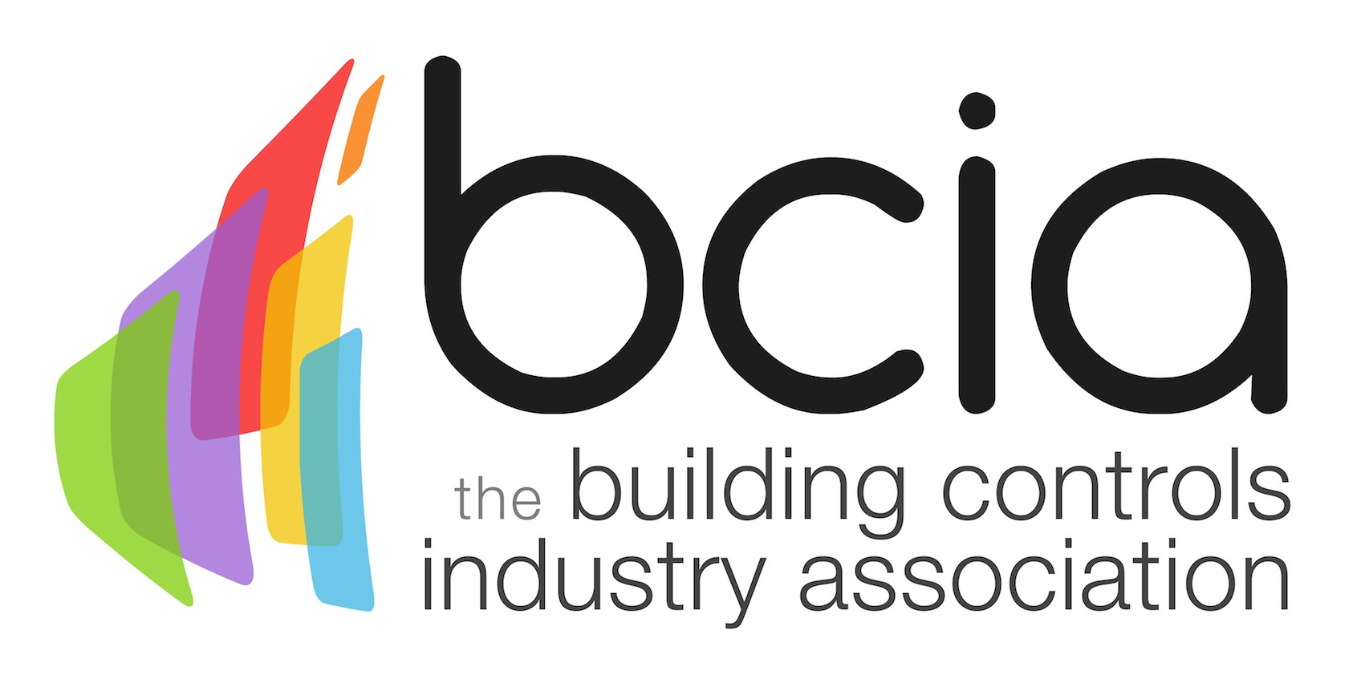

Press Release

22 March 2019

Building Controls Industry Association celebrates 100 members
The Building Controls Industry Association (BCIA) is delighted to announce that it now has a grand total of 100 members. The recent addition of Kernow Controls has enabled the BCIA to celebrate this important milestone.

The Association is continuing to grow year on year and members of the BCIA play a pivotal role in raising the profile of the Association by contributing towards useful resources such as the new BEMS Performance Specification. What’s more, the BCIA Marketing, Skills and Technical Working Groups meetings bring like-minded people together to raise performance standards, promote training opportunities and reach out to other organisations and government bodies to ensure that building controls are top of the agenda.

The latest figures from the BCIA’s Market Information Services (MIS) show that during the 2018 calendar year a new record was set for the value of the total controls and BEMS market in the UK at £695.6 million, underlining the increasing profile of building controls.

As the Association grows, the BCIA has added a new category of Corporate Membership: Enterprise Membership. There are now two membership categories available, the newly added Enterprise and the original Full Membership.

Members of the BCIA receive discounted training, access to the Market Information Service, free membership of FETA (Federation of Environmental Trade Associations), as well as special rates for a selection of industry events and insightful publications.

Find out more by visiting the BCIA website: www.bcia.co.uk

Jon Belfield, President of the BCIA said: “It gives me great pleasure to welcome Kernow Controls to the BCIA and to celebrate the hugely significant landmark of reaching 100 members. We work with companies from all over the UK, bringing their expertise into the mix and tapping into the professional training capability that we have collectively.”

Lucie Hackney, Office Manager of Kernow Controls revealed: “We are very proud to have become the 100th member of the BCIA. It is a testament to the dedication and commitment of the Association and its members that it continues to grow and help steer the building controls industry forward.”

Note to editors
The Building Controls Industry Association (BCIA) represents the UK building controls and BEMS sector. With around 100 members accounting for 80% of the UK controls market, the BCIA is an influential group that promotes better specification, application and use of controls. The BCIA also offers its own training courses and is currently supporting a new Trailblazer Apprenticeship Standard for the industry which is being developed by the BEMS Employer Group.

For further information about the BCIA please contact Keystone Communications:

Tracey Rushton-Thorpe
Tel: 01733 294524
Email: tracey@keystonecomms.co.uk

Leandra Graves
Tel: 01733 294524
Email: leandra@keystonecomms.co.uk

