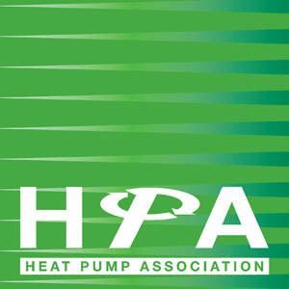

Press Release
2nd May 2019

The HPA responds to Committee on Climate Change Net Zero report

The Heat Pump Association (HPA), as the UK’s leading authority on the use and benefits of heat pump technology, welcomes the publication today of the Committee on Climate Change’s Net Zero report, which highlights that a net-zero target for UK greenhouse gas emissions by 2050 is both achievable and will deliver on the UK’s Paris Agreement commitments. The HPA agrees with the Committee that reaching this target is feasible with already available technologies, such as heat pumps, which are vital in the decarbonisation of UK heating systems.

Crucially, the report highlights the need for the Government to act immediately to implement a clear regulatory framework to achieve the decarbonisation of heat and recommends a range of policies to do so. The policy recommendations of the report include support for low carbon heating, a review of the balance of tax and regulatory costs across fuels, and a nationwide training programme to upskill the existing workforce. The HPA is pleased to see these recommendations as a means of reflecting the benefits of low carbon technologies and aims to work with all stakeholders to develop effective policy starting with the upcoming Part L Review and consultation on the regulatory framework for the future of heat to phase out high carbon fossil fuels.

Graham Wright, HPA Chairman, commented: “The HPA wholeheartedly supports the report’s recognition that urgent action is required to meet a net-zero target and welcomes the specific recommendations for decarbonising heat within the publication.

“Momentum is now gathering among the public acknowledging the need to change the way we heat our buildings and, as highlighted in the report, known technologies, such as heat pumps, offer a clear solution for this.

“Heat pumps offer an extensive opportunity to reduce the UK’s emissions, as well as helping to address other policy issues such as fuel poverty and air quality. The Future Homes standard set to be introduced in 2025, and supported within this report, represents the ‘low-hanging fruit’ of heating in new builds, which, in addition to those properties off the gas grid, should be the immediate focus for the Government.”
Notes to Editors

The Committee on Climate Change Report ‘Net Zero: the UK’s contribution to stopping global warming’ is available here.
The Heat Pump Association is the UK’s leading authority on the use and benefits of heat pump technology and includes many of the country’s leading manufacturers of heat pumps, components and associated equipment. The Heat Pump Association is part of the Federation of Environmental Trade Associations.

www.heatpumps.org.uk

For further information, please contact Keystone Communications:

Michael Crane
Tel: 01733 294524
Email: russell@keystonecomms.co.uk

Russell Drury
Tel: 01733 294524
Email: russell@keystonecomms.co.uk

