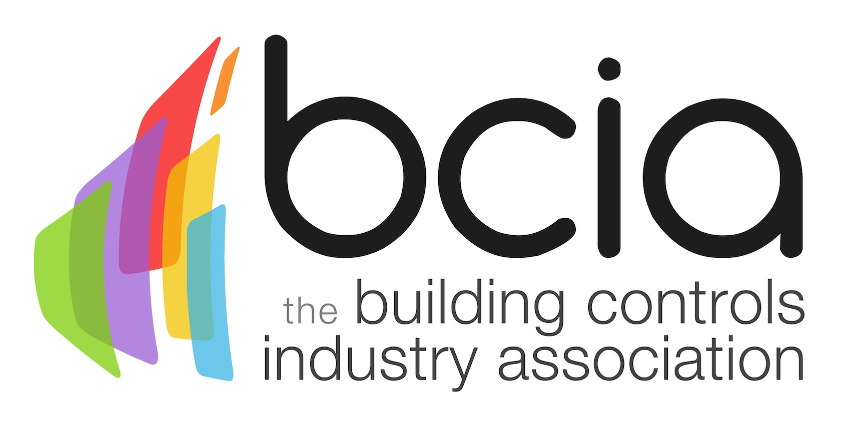

Press Release

10 May 2019

2019 BCIA Awards winners revealed
The winners of the 2019 Building Controls Industry Association (BCIA) Awards were announced at an exclusive ceremony and gala dinner on 09 May at the swanky Hilton Birmingham Metropole Birmingham.

Multi-award winning comedian and writer Holly Walsh hosted this year’s distinguished awards which saw not only a record number of entries but also a record number of guests. Anyone who is anyone was in attendance to see the industry’s finest enjoy their well-earned moment in the spotlight.

The first accolade of the night went to Eton Associates for Independent Building Controls & BEMS Installer of the Year as a result of their lasting customer relationships, professionalism and understanding of clients’ needs.

Next up was the Engineer of the Year Award, which was presented to Ian Dalby, a Senior Systems Engineer for System Five. Along with his enthusiasm, Ian has demonstrated exceptional attention to detail, outstanding customer service skills and a willingness to help others.

The Young Engineer of the Year Award saw a record 12 finalists and it was Luke Williamson of Eton Associates were triumphant amongst fierce competition. Luke has been a key player in high-profile projects and has thrived under such demands using both his technical abilities and resilience. Furthermore, he has successfully completed all of the BCIA courses as well as additional qualifications.

Optimised Buildings clinched the Energy Management Award for their energy saving projects in Superdry Stores throughout the UK. Following new strategies implemented by Optimised Buildings, Superdry Stores saw a 14% reduction in electricity consumption and a Return on Investment (ROI) in just four months.

Following this, Demand Logic scooped the Best Service and Maintenance Provider Award which best demonstrates outstanding levels of customer care in the provision of long-term service and maintenance contracts for Building Energy Management Systems (BEMS) and building controls.

Innovation is at the forefront of the building services industry and IAconnects emerged victorious in the coveted Technical Innovation of the Year – Products Award with their forward-thinking MobiusFlow Edge Gateway, an IoT solution that enables actuators, sensors and controllers to connect, control and communicate with each other and the Cloud.

Equally impressive were the winners of the Technical Innovation of the Year – Projects Award: Econowise Drives & Controls, for their 99 Gresham Street Bubll Installation. Bubll has provided a very cost effective, fully featured wireless connected environment to allow full user interactivity and data harvesting.

One Sightsolutions claimed the honour of the Contribution to Training Award with their newly available and free online training videos, demonstrating their ongoing commitment to further the knowledge of those within the industry.

The final award on the night was for Outstanding Contribution of the Year and was presented to Wendy Belfield of InTandem Systems. Wendy has demonstrated her ongoing commitment and dedication in making the BEMS Controls Engineer Trailblazer Apprenticeship Standard come to fruition, which will play a pivotal role in tackling the skills gap. This will significantly impact the future careers of many people who have yet to enter our industry. Without Wendy’s efforts we would not be in this position today.

Jon Belfield, President of the BCIA, said: “The BCIA Awards were once again a wonderful occasion and it was a joy to celebrate the crème de la crème of the building controls industry. I would like to offer my congratulations to all of the winners and thank all of the sponsors and media partners for their continued support.”

Note to editors
The Building Controls Industry Association (BCIA) represents the UK building controls and BEMS sector. With around 100 members accounting for 80% of the UK controls market, the BCIA is an influential group that promotes better specification, application and use of controls. The BCIA also offers its own training courses and is currently supporting a new Trailblazer Apprenticeship Standard for the industry which is being developed by the BEMS Employer Group.

For further information about the BCIA please contact Keystone Communications:

Tracey Rushton-Thorpe
Tel: 01733 294524
Email: tracey@keystonecomms.co.uk

Leandra Graves
Tel: 01733 294524
Email: leandra@keystonecomms.co.uk

