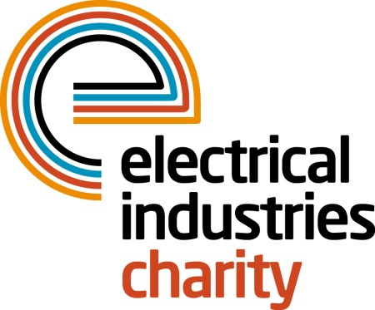
Press Release

24 July 2019

Explore the magical Inca trail with EIC’s Challenge for a Cause 2020

The Electrical Industries Charity (EIC) is giving you an amazing opportunity to follow in the footsteps of a great lost civilisation with its fifth Challenge for a Cause – Inca Trail 2020. Are you up for a challenge? If so, book your place now and do something incredible in the new year.

The ten-day spectacular Inca Trail challenge will give you a chance to discover the beauty of Peru as you trek through a stunning combination of ruins of a mystical ancient city, mountain capes, and tropical cloud forests. As part of this adventure, you will also tackle the demanding Dead Woman’s Pass, which stands at 4,200m and eventually you will reach the Sun Gate that overlooks the stunning Machu Picchu. Once you catch your first glimpse of Machu Picchu in the early morning light, you will know it was all worthwhile.

Inca Trail is the most famous hike in South America – perhaps the world – and a must-do, life-changing experience. Hiking the Inca Trail through the Sacred Valley to Machu Picchu is both arduous and awe-inspiring and will leave you with unforgettable memories to cherish for many years to come.

What’s more, during this magnificent challenge you will not only get to join EIC’s Managing Director, Tessa Ogle on the journey of a lifetime but will also help EIC to be first port of call to hundreds of your industry colleagues’ and their families by allowing the Charity to offer financial, practical and emotional support in their hour of need. So, what are you waiting for? Put that tick on the bucket list next to ‘visit Machu Picchu’ by signing up to trek the Inca Trail and be awed by a civilisation that ruled as the backbone of the Andes for nearly a century.

The once in a lifetime Inca Trail Challenge for a Cause is taking place between 5th September 2020 – 15th September 2020. Book your place now and get ready to discover one of the new Seven Wonders of the World. Hurry, permits to the Inca Trail are restricted and must be secured by November 2019, so register your interest today to avoid disappointment. Only five places remain for this challenge and the fundraising target is £5,000, plus a registration fee of £499.

For further information or to secure your place, please contact Jess Vailima: jess.vailima@electricalcharity.org

https://www.electricalcharity.org/index.php/events/18-events/335-inca-trail-2020

Note to editors
The Electrical Industries Charity is the national charity for the electrical, electronics and energy industries. It aims to look after people from these industries whenever they, or their families need help with life’s challenges. It provides information, financial grants and practical support on a range of everyday issues including; work, family, relationships, money and health.

The charitable services are available to anyone who currently works or has worked in the very diverse and often converging industries, such as:
- Electrical contracting and facilities management
- Electrical and electronic manufacturing, wholesale, distribution and retail
- Electrical and mechanical engineering
- Lighting industry
- Generation, distribution and supply of electrical power, including nuclear and renewable energy

For further information about the Electrical Industries Charity please contact Keystone Communications:

Tracey Rushton-Thorpe Monika Gaubyte
Tel: 01733 294524 Tel: 01733 294524
Email: tracey@keystonecomms.co.uk Email: monika@keystonecomms.co.uk

