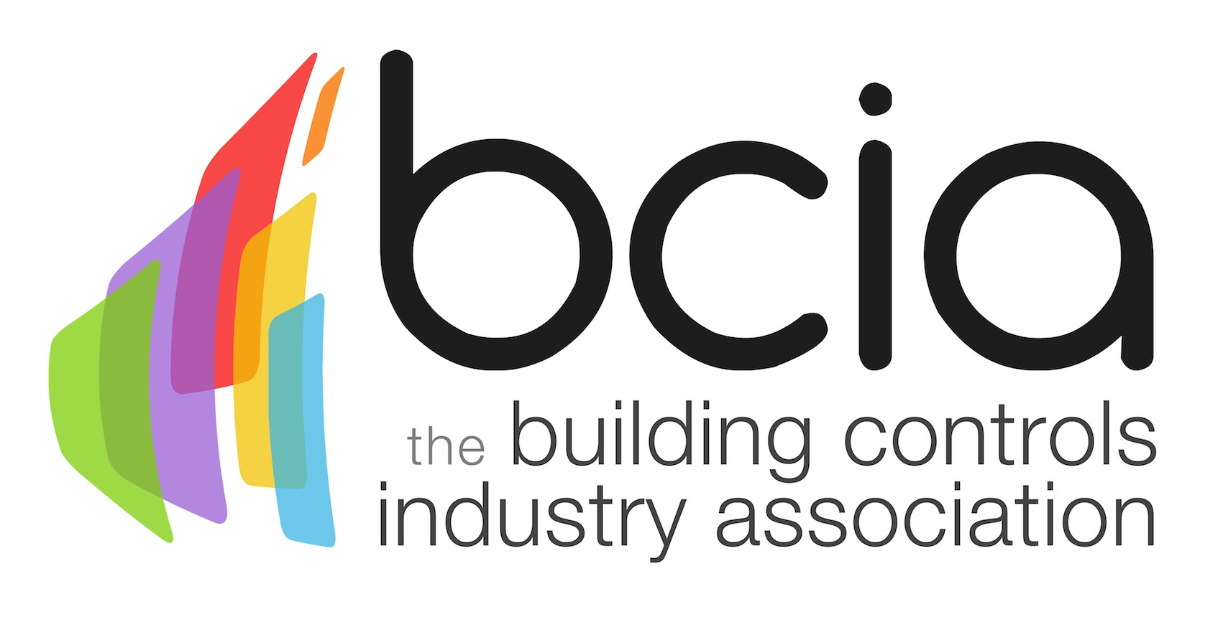

Press Release

24 June 2019

One small change, one big difference

The Building Controls Industry Association (BCIA) is encouraging people in the building controls sector to make one small change to their everyday lives to improve energy efficiency in buildings and create a more sustainable future.

Many people in the building controls industry might think that issues surrounding climate change are too big to be fixed and that their actions will not make much difference. However, if each one of us takes one small step towards changing everyday habits in the workplace, such as closing the window when the air conditioning is on, turning off the lights in the rooms that we do not use, or perhaps something more complicated such as changing the control strategy to change a chiller setpoint based on overall cooling demand, together, we can indeed make a big difference in the long-term.

Recently, Energy Live News statistics revealed that the UK electricity system loses £9.5 billion per year on wasted energy, mainly through heat. When all the small changes are combined, the building controls industry can erode the wasted energy that these alarming statistics clearly define.

Changing one small thing enables you to change another small thing – until little by little, everything you have wanted to change, changes. By simply implementing small changes in your everyday lives you can lead the way in improving energy efficiency in today’s sophisticated commercial buildings and share best practice so our ‘small changes’ make the big change that we wish to see.

Jon Belfield, President of the BCIA, says: “It is abundantly clear that highly trained, smart BEMS engineers are already making innovative and effective changes to play a huge role in improving energy efficiency and at the same time, making buildings more comfortable for occupants. This professional approach to improve the overall performance of buildings is critical in ensuring the sector continues to grow and remains strong over the coming years.

“Therefore, I would like to challenge everyone in the building controls industry to share their own method(s) of saving energy in a building or your workplace be they large or small, it is the combined difference that we make together that will make the overall change we wish to see. Post it on Twitter, LinkedIn or your website with the hashtag #OneSmallChange and let’s see what we can learn from each other while collectively improving today’s commercial buildings.”

Are you up for a challenge? If so, make a change today and don’t forget to share your everyday achievements on social media using #OneSmallChange to encourage and inspire others to do the same.

For further information, visit www.bcia.co.uk

Note to editors

The Building Controls Industry Association (BCIA) represents the UK building controls and BEMS sector. With around 100 members accounting for 80% of the UK controls market, the BCIA is an influential group that promotes better specification, application and use of controls. The BCIA also offers its own training courses and is currently supporting a new Trailblazer Apprenticeship Standard for the industry which is being developed by the BEMS Employer Group.

For further information about the BCIA please contact Keystone Communications:

Tracey Rushton-Thorpe
Tel: 01733 294524
Email: tracey@keystonecomms.co.uk

Leandra Graves
Tel: 01733 294524
Email: leandra@keystonecomms.co.uk

