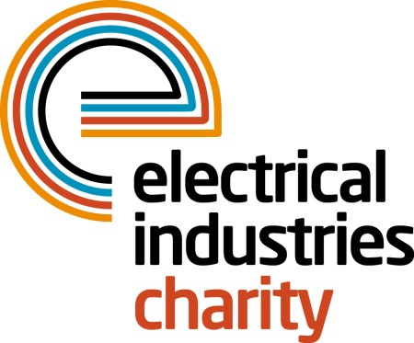
Press Release

26 June 2019

Get practical with EIC

Would you like to make a life-changing difference in your colleagues’ or their families’ lives? The Electrical Industries Charity (EIC) is presenting you with an incredible opportunity to get practical and help those in need by signing up to the Practical Participation Programme (PPP).

The Practical Participation Programme which is part of the Employee Assistance Programme (EAP) and is funded by powerLottery, offers companies within the electrical sector a chance to get involved by volunteering their time, equipment and materials to provide the best practical support to people in the electrical industry.

Through PPP, you can help EIC to offer practical support to people like Elliott Angell. Elliott was born prematurely at 31 weeks in 2013 and suffered brain damage due to a lack of oxygen. This resulted in diplegic cerebral palsy which affects both of his legs, causing severe stiffness and making him unable to sit or walk unaided. Recently Elliott was offered life-changing surgery - Selective Dorsal Rhizotomy (SDR) - which will allow him to walk and play football with his little sister and his friends, however, the operation and physiotherapy is not covered by the NHS and comes at a huge cost of £75,000.

To fulfil Elliott’s dream of walking alongside his siblings and friends, his family created a social media fundraising campaign called ‘Finding Elliott’s Feet’ which gives people like you an opportunity to show your support and follow Elliott’s journey.

The Angell family also contacted EIC for support and the Charity assisted by providing finance for monthly physiotherapy sessions and travel costs as well as helping the family with their current housing situation which is not suitable for Elliott’s needs. In addition, Elliott recently received a brand-new wheelchair from EIC which is allowing him to be more independent.

Over the years, thanks to support from the industry, EIC has helped many people like Elliott to have a better quality of life by offering them financial and practical assistance in their times of difficulty, but there are many more people within the electrical sector who are struggling to cope and need your support. So, why not become a partner of PPP today and give your colleagues’ a chance at life? Alternatively, you can also take part in powerLottery by simply downloading the EIC powerLottery app and tapping the app to play.

For further information, please contact Jess Vailima: jess.vailima@electricalcharity.org

www.electricalcharity.org

Note to editors
The Electrical Industries Charity is the national charity for the electrical, electronics and energy industries. It aims to look after people from these industries whenever they, or their families need help with life’s challenges. It provides information, financial grants and practical support on a range of everyday issues including; work, family, relationships, money and health.

The charitable services are available to anyone who currently works or has worked in the very diverse and often converging industries, such as:
- Electrical contracting and facilities management
- Electrical and electronic manufacturing, wholesale, distribution and retail
- Electrical and mechanical engineering
- Lighting industry
- Generation, distribution and supply of electrical power, including nuclear and renewable energy

For further information about the Electrical Industries Charity please contact Keystone Communications:

Tracey Rushton-Thorpe Monika Gaubyte
Tel: 01733 294524 Tel: 01733 294524
Email: tracey@keystonecomms.co.uk Email: monika@keystonecomms.co.uk

