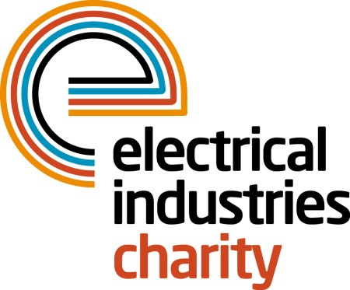
Press Release

20 August 2019

Step outside your comfort zone by taking on a challenge for EIC

Are you an enthusiastic individual who is looking for a new challenge that would push you to the limits? If so, the Electrical Industries Charity (EIC) has a challenge for everyone to get involved in and create some everlasting memories while supporting your industry colleagues.

You can make a difference and help EIC to offer continuous support for hundreds of people within the electrical sector by taking part in a wide range of sporting challenges, such as running for the Charity in the 2020 Virgin Money London Marathon, taking part in EIC golf or fishing days, or by creating your own challenge. You can also get involved by attending some of the biggest industry events, including powerBall 2019, the Western Equinox Ball, one of the 2019 Christmas Lunches held in a wide range of locations, Valentine’s Ball 2020 and many more glitzy and glamorous events.

If exploring the lost civilizations is more your thing, strap on your walking boots and enjoy the beauty of Peru while exploring ancient Inca ruins on your way to one of the Wonders of the World – Machu Picchu. This trip is a once-in-a-lifetime opportunity to experience unforgettable sights in one of the most incredible places on earth. If you have ever wanted to catch a glimpse of Machu Picchu, then this one is for you! Only four places remain. So, register your interest today to witness the Peruvian paradise. All you need to do to take part in this incredible Challenge for a Cause is sign up and raise £5,000. The Inca Trail challenge is taking place between 05 September – 14 September 2020.

Alternatively, you can also show your support by becoming a partner of EIC’s Employee Assistance Programme (EAP), by playing powerLottery for as little as £1 per month by downloading the powerLottery app or by signing up to easyfundraising, which donates a percentage of sales to the EIC at no cost to you. Simply by registering your details at easyfundraising.org.uk you will be fundraising for the EIC every time you shop.

So, what are you waiting for? Step outside your comfort zone and give back to your industry, while raising money for EIC by taking part in one or more of the challenges today.

For further information or if you would like to sign up to one of the incredible challenges, please contact Jess Vailima: jess.vailima@electricalcharity.org

www.electricalcharity.org

Note to editors
The Electrical Industries Charity is the national charity for the electrical, electronics and energy industries. It aims to look after people from these industries whenever they, or their families need help with life’s challenges. It provides information, financial grants and practical support on a range of everyday issues including; work, family, relationships, money and health.

The charitable services are available to anyone who currently works or has worked in the very diverse and often converging industries, such as:
- Electrical contracting and facilities management
- Electrical and electronic manufacturing, wholesale, distribution and retail
- Electrical and mechanical engineering
- Lighting industry
- Generation, distribution and supply of electrical power, including nuclear and renewable energy

For further information about the Electrical Industries Charity please contact Keystone Communications:

Tracey Rushton-Thorpe Monika Gaubyte
Tel: 01733 294524 Tel: 01733 294524
Email: tracey@keystonecomms.co.uk Email: monika@keystonecomms.co.uk

